 | 

Alternative Assessment Tool (AAT) Report on

“Design and Verification of Combinational and Sequential Digital Modules using Verilog HDL”
Submitted in partial fulfilment of the requirements of the Alternative Assessment Tool (AAT) for the course

ADVANCED DIGITAL AND LOGIC DESIGN (ADLD)
[Course Code: 23ECSPE1AD]

Submitted by

Vismitha JS | 1BF24EC189

Submitted to

Prof. Ajaykumar Devarapalli

DEPARTMENT OF ELECTRONICS AND COMMUNICATION ENGINEERING
BMS College of Engineering
Bull Temple Road, Basavanagudi, Bengaluru-560019

Academic Year
2026 – 2027

INDEX

S.NO | CONTENTS | PAGE NO
1 | Arithmetic Logic Unit (ALU) | 2-7
2 | Comparator | 7-11
3 | 4-Bit Parity Generator and Checker | 11-13
4 | 4-Bit Barrel Shifter | 13-16
5 | Timer Module | 17-20
6 | Ring Counter | 20-22
7 | Johnson Counter | 23-25
8 | Synchronous and Asynchronous Counters | 25-30
9 | Shift Register | 31-34
10 | Divide-by-N Counter | 34-37
11 | Mealy and Moore FSMs | 38-44
12 | Random Sequence Generator | 44-46
13 | Acknowledgment | 47

1. Arithmetic Logic Unit (ALU)
To design and implement a 4-bit Arithmetic Logic Unit (ALU) using Verilog HDL in Xilinx Vivado. The ALU performs arithmetic and logical operations on two 4-bit input operands based on a 3-bit selection signal. The design is verified using a Verilog testbench and behavioural simulation.
DESIGN:
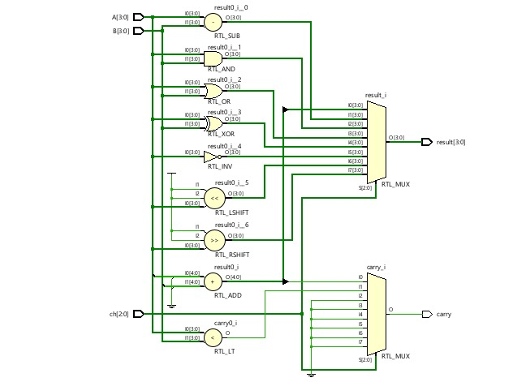
Code:
`timescale 1ns / 1ps
module alu (
input wire [3:0] A,
input wire [3:0] B,
input wire [2:0] ch,
output reg [3:0] result,
output reg carry
);
always @(*) begin
// Default values
result = 4'b0000;
carry = 1'b0;
case (ch)
// Addition
3'b000: begin
{carry, result} = {1'b0, A} + {1'b0, B};
end
// Subtraction
3'b001: begin
result = A - B;
carry = (A < B);
end
// Bitwise AND
3'b010: begin
result = A & B;
end

// Bitwise OR
3'b011: begin
result = A | B;
end
// Bitwise XOR
3'b100: begin
result = A ^ B;
end
// Bitwise NOT
3'b101: begin
result = ~A;
end
// Left shift
3'b110: begin
result = A << 1;
end
// Right shift
3'b111: begin
result = A >> 1;
end
default: begin
result = 4'b0000;
carry = 1'b0;
end
endcase
end
endmodule
TESTBENCH:
`timescale 1ns / 1ps
module alu_tb;
reg [3:0] A;
reg [3:0] B;
reg [2:0] ch;
wire [3:0] result;
wire carry;
// Instantiate the ALU
alu uut (
.A(A),
.B(B),
.ch(ch),
.result(result),
.carry(carry)
);
initial begin
$display("Time | A | B | ch | result | carry");
$monitor("%4t | %b | %b | %b | %b | %b",
$time, A, B, ch, result, carry);
// 1. Addition: 12 + 7 = 19
A = 4'b1100;
B = 4'b0111;
ch = 3'b000;
#10;
// 2. Subtraction: 3 - 9
A = 4'b0011;
B = 4'b1001;
ch = 3'b001;
#10;
// 3. Bitwise AND
A = 4'b1100;
B = 4'b1010;
ch = 3'b010;
#10;
// 4. Bitwise OR
ch = 3'b011;
#10;
// 5. Bitwise XOR
ch = 3'b100;
#10;
// 6. Bitwise NOT of A
ch = 3'b101;
#10;
// 7. Left shift A by 1
A = 4'b0101;
B = 4'b0000;
ch = 3'b110;
#10
// 8. Right shift A by 1
ch = 3'b111;
#10;

$display("All 8 ALU operations tested.");
$finish;
end
endmodule

WAVEFORM:
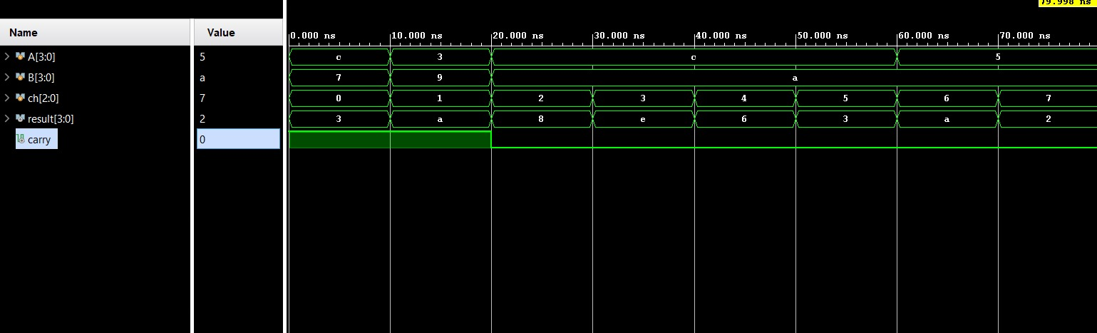

BLOCK DIAGRAM:
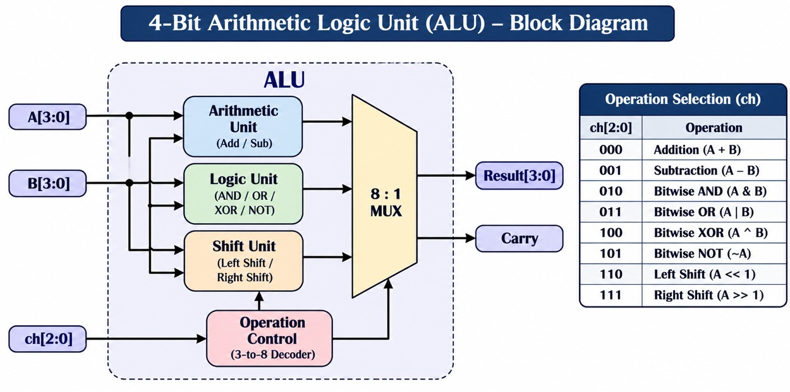
2. Comparator
To design and implement a 4-bit magnitude comparator using Verilog HDL in Xilinx Vivado. The comparator compares two 4-bit input operands and determines whether the first operand is greater than, less than, or equal to the second operand. The design is verified using a Verilog testbench and behavioural simulation.
DESIGN:
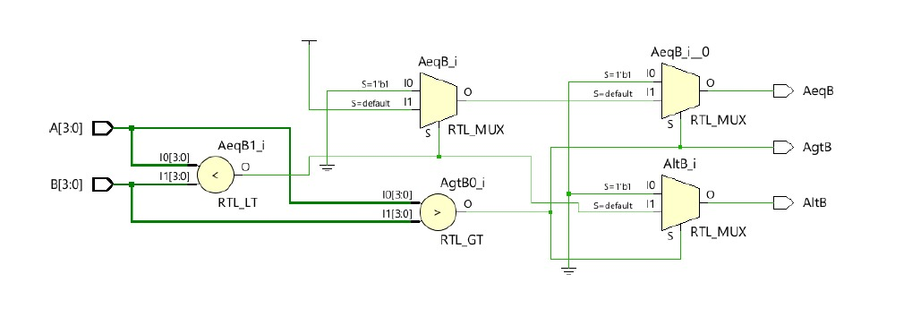
CODE:
`timescale 1ns / 1ps
module comparator (
input wire [3:0] A,
input wire [3:0] B,
output wire AeqB,
output wire AgtB,
output wire AltB
);
// Comparator blocks
wire lt;
wire gt;
assign lt = (A < B);
assign gt = (A > B);
// Equality output using conditional logic
assign AeqB = lt ? 1'b0 :
gt ? 1'b0 : 1'b1;

// Greater-than output
assign AgtB = lt ? 1'b0 : gt;
// Less-than output
assign AltB = gt ? 1'b0 : lt;
endmodule
TESTBENCH:
`timescale 1ns / 1ps
module comparator_tb;
reg [3:0] A;
reg [3:0] B;
wire AeqB;
wire AgtB;
wire AltB;
// Instantiate the comparator
comparator uut (
.A(A),
.B(B),
.AeqB(AeqB),
.AgtB(AgtB),
.AltB(AltB)
);
initial begin
// Test 1: A > B (12 > 5)
A = 4'd12;
B = 4'd5;
#10;
// Test 2: A < B (4 < 15)
A = 4'd4;
B = 4'd15;
#10;
// Test 3: A = B (7 = 7)
A = 4'd7;
B = 4'd7;
#10;
// Test 4: Maximum value versus minimum
A = 4'd15;
B = 4'd0;
#10;
// Test 5: Minimum value versus maximum
A = 4'd0;
B = 4'd15;
#10;
// Test 6: Adjacent values (8 < 9)
A = 4'd8;
B = 4'd9;
#10;
// Test 7: Only the least significant bit differs (11 > 10)
A = 4'b1011;
B = 4'b1010;
#10;
$finish;
end
endmodule
WAVEFORM: 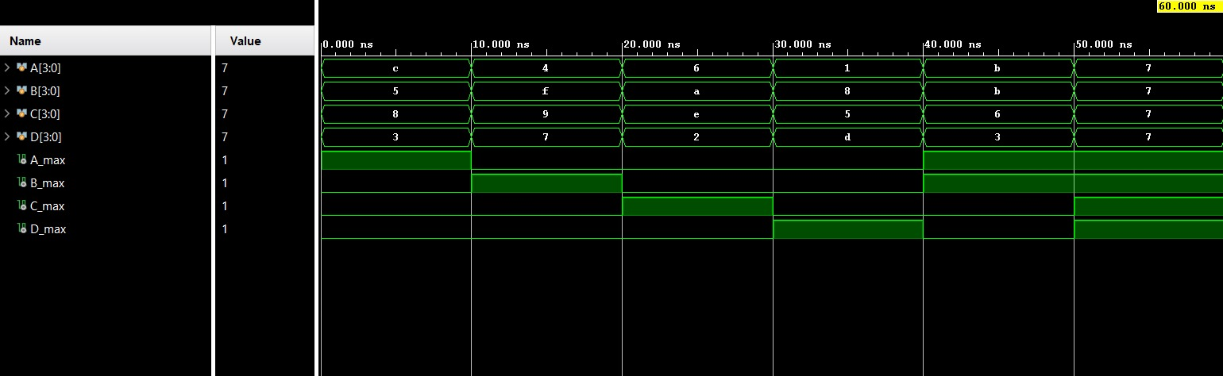

BLOCK DIAGRAM:
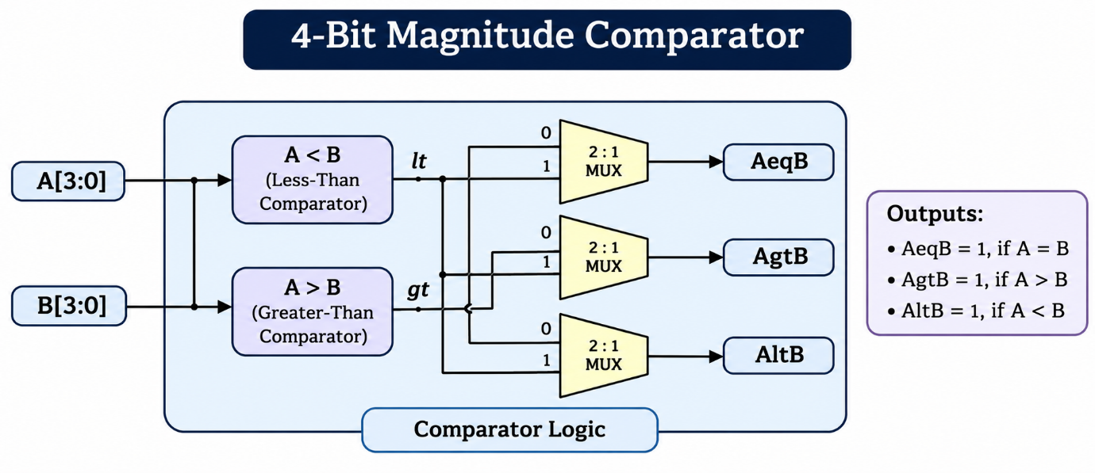

3. 4-Bit Parity Generator and Checker
A 4-bit Parity Generator and Checker is a digital circuit designed to generate and verify parity bits for error detection during data transmission. The parity generator uses XOR operations to produce an even-parity bit for a 4-bit input. The parity checker compares the received parity bit with the expected parity and indicates whether an error has occurred. The design is implemented using Verilog HDL in Xilinx Vivado and verified through a testbench and behavioural simulation.

DESIGN:
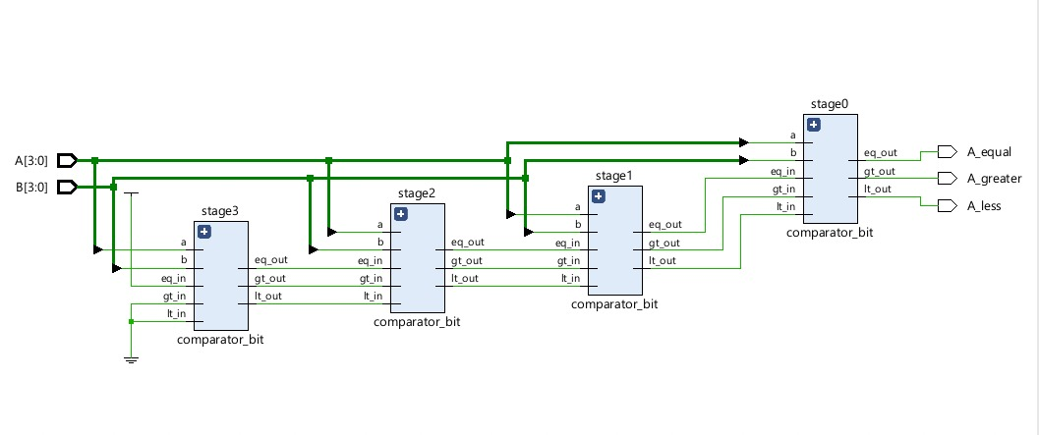
CODE:
`timescale 1ns / 1p
module parity (
input wire [3:0] data,
input wire parity_in,
output wire even_parity,
output wire odd_parity,
output wire error
);
assign even_parity = ^data;
assign odd_parity = ~^data;
// Error detection for even-parity data
assign error = ^{data, parity_in}
endmodule
TESTBENCH:
`timescale 1ns / 1ps
module parity_tb;
reg [3:0] data;
reg parity_in;
wire even_parity, odd_parity, error;

parity uut (
.data(data), .parity_in(parity_in),
.even_parity(even_parity),
.odd_parity(odd_parity), .error(error)
);
initial begin
data = 4'b0000; parity_in = 0; #10;
data = 4'b1011; parity_in = 1; #10;
data = 4'b1100; parity_in = 0; #10;
data = 4'b1111; parity_in = 1; #10;
$finish;
end
endmodule
WAVEFORM:
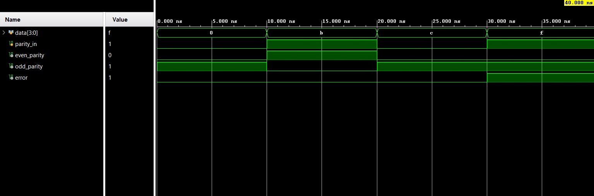
BLOCK DIAGRAM:
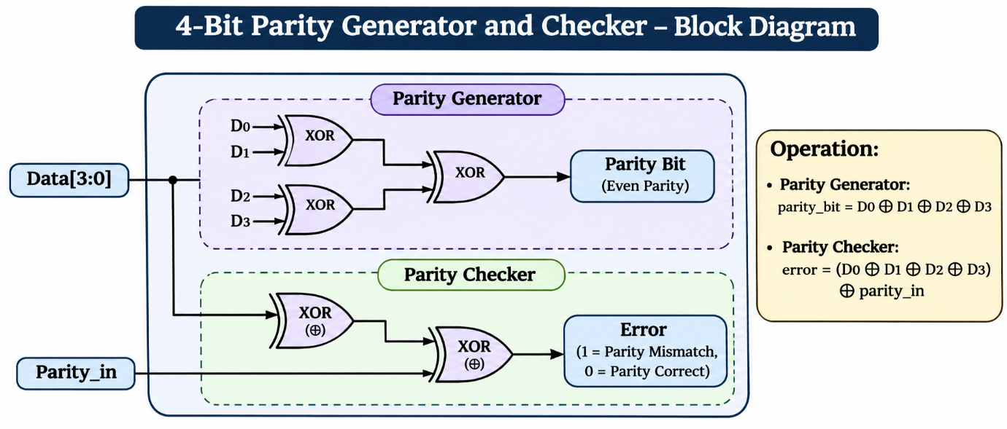
4. 4-Bit Barrel Shifter
A 4-bit barrel shifter is a combinational digital circuit that shifts or rotates a 4-bit input according to the selected control signals. It supports four operations: no shift, right shift by one bit, left shift by one bit, and rotate left by one bit. The circuit is implemented using Verilog HDL in Xilinx Vivado and verified through a testbench and behavioural simulation.
DESIGN:
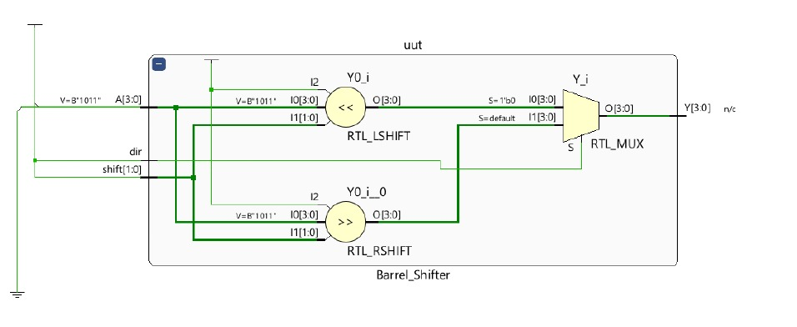
CODE:
`timescale 1ns / 1ps
module barrel_shifter(
input wire [3:0] A,
input wire [1:0] S,
output reg [3:0] Y
);
always @(*) begin
case (S)
2'b00: Y = A; // No shift
2'b01: Y = A >> 1; // Right shift by 1
2'b10: Y = A << 1; // Left shift by 1
2'b11: Y = {A[2:0], A[3]}; // Rotate left by 1
default: Y = A;
endcase
end
endmodule
TESTBENCH:
`timescale 1ns / 1ps
module barrel_shifter_tb
reg [3:0] A;
reg [1:0] S;
wire [3:0] Y;
barrel_shifter uut (
.A(A),
.S(S),
.Y(Y)
);
initial begin
$monitor("Time=%0t | A=%b | S=%b | Y=%b",
$time, A, S, Y);
// Test 1: No shift
A = 4'b1101;
S = 2'b00;
#10;
if (Y !== 4'b1101)
$display("TEST 1 FAILED");
else
$display("TEST 1 PASSED");
// Test 2: Right shift by 1
A = 4'b1101;
S = 2'b01;
#10;
if (Y !== 4'b0110)
$display("TEST 2 FAILED");
else
$display("TEST 2 PASSED");
// Test 3: Left shift by 1
A = 4'b1101;
S = 2'b10;
#10;
if (Y !== 4'b1010)
$display("TEST 3 FAILED");
else
$display("TEST 3 PASSED");

// Test 4: Rotate left by 1
A = 4'b1101;
S = 2'b11;
#10;
if (Y !== 4'b1011)
$display("TEST 4 FAILED");
else
$display("TEST 4 PASSED");
$display("All test cases completed.");
$finish;
end
endmodule

WAVEFORM:
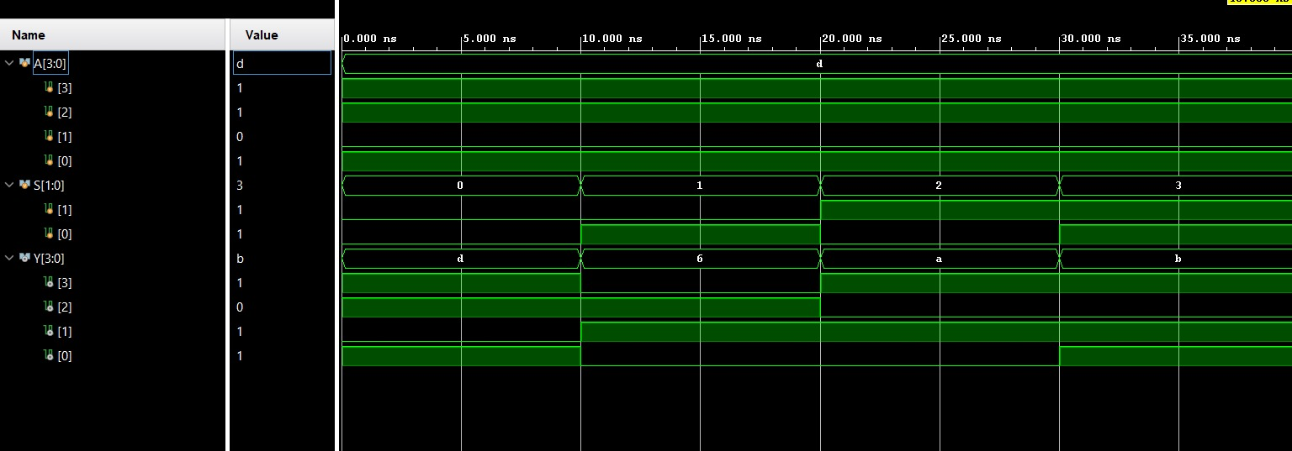
BLOCK DIAGRAM:
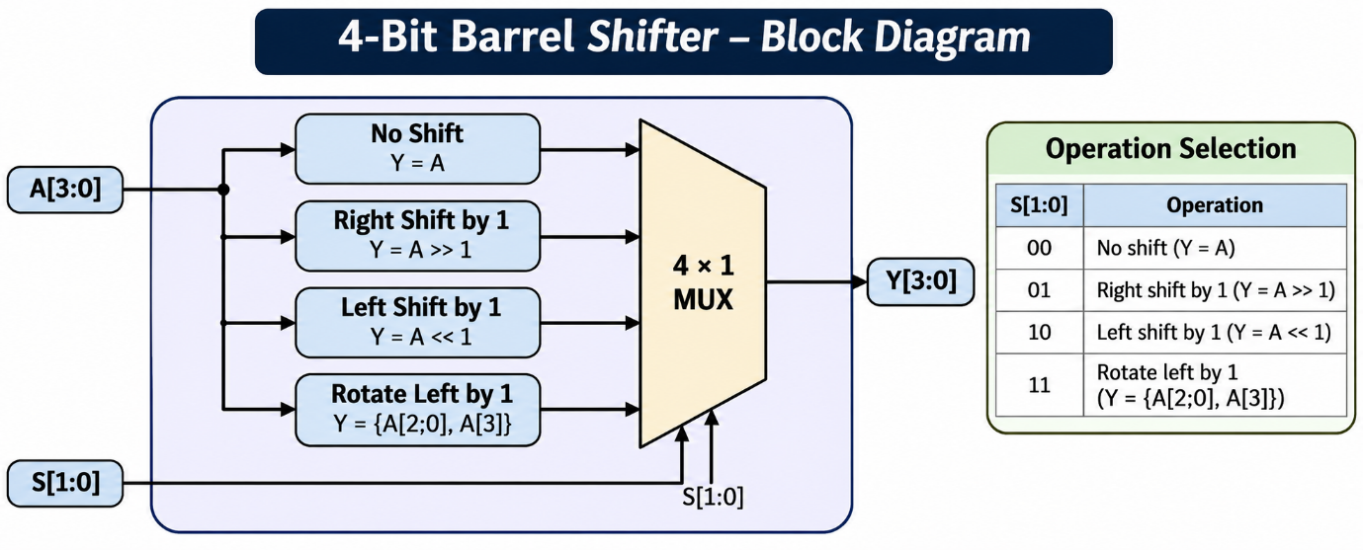

5. Timer Module
A timer module is a digital circuit designed using Verilog HDL to measure time intervals by counting clock pulses. It consists of a counter that increments with each clock cycle until a predefined count is reached, after which the timer generates an output signal or resets the counter. The timer module is implemented in Xilinx Vivado and verified using a testbench and behavioural simulation to ensure correct timing and counting operation.
DESIGN: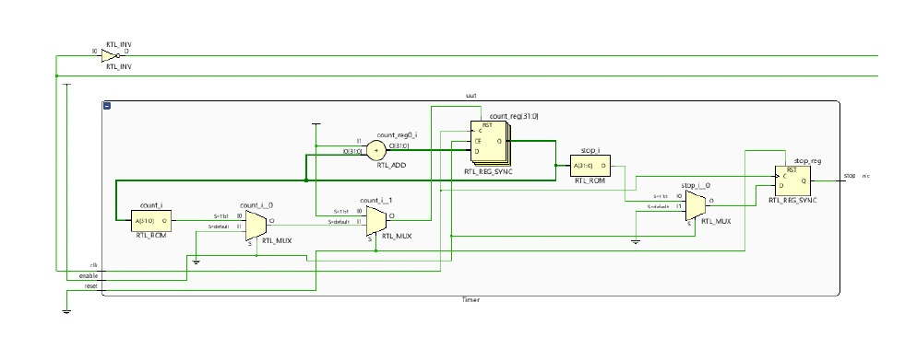
CODE:
`timescale 1ns / 1ps
module Timer #(
parameter COUNT_MAX = 5
)(
input clk,
input reset,
input enable,
output reg stop
);
reg [31:0] count;
always @(posedge clk) begin
if (reset) begin
count <= 0;
stop <= 0;
end
else if (enable) begin
if (count == COUNT_MAX - 1) begin
count <= 0;
stop <= 1;
end
else begin
count <= count + 1;
stop <= 0;
end
end
else begin
stop <= 0;
end
end
endmodule
TESTBENCH:
`timescale 1ns / 1ps
module Timer_tb;
reg clk, reset, enable;
wire stop;
Timer #(.COUNT_MAX(5)) uut (
.clk(clk),
.reset(reset),
.enable(enable),
.stop(stop)
);
always #5 clk = ~clk;
initial begin
$monitor("Time=%0t | reset=%b | enable=%b | stop=%b",
$time, reset, enable, stop);

clk = 0;
reset = 1;
enable = 0;
#10;
reset = 0;
enable = 1;
#70;
enable = 0;
#20;
enable = 1;
#40;
$finish;
end
endmodule
WAVEFORM:
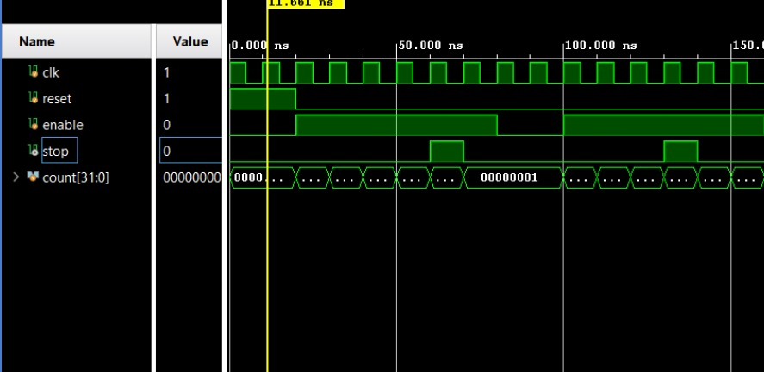

BLOCK DIAGRAM:
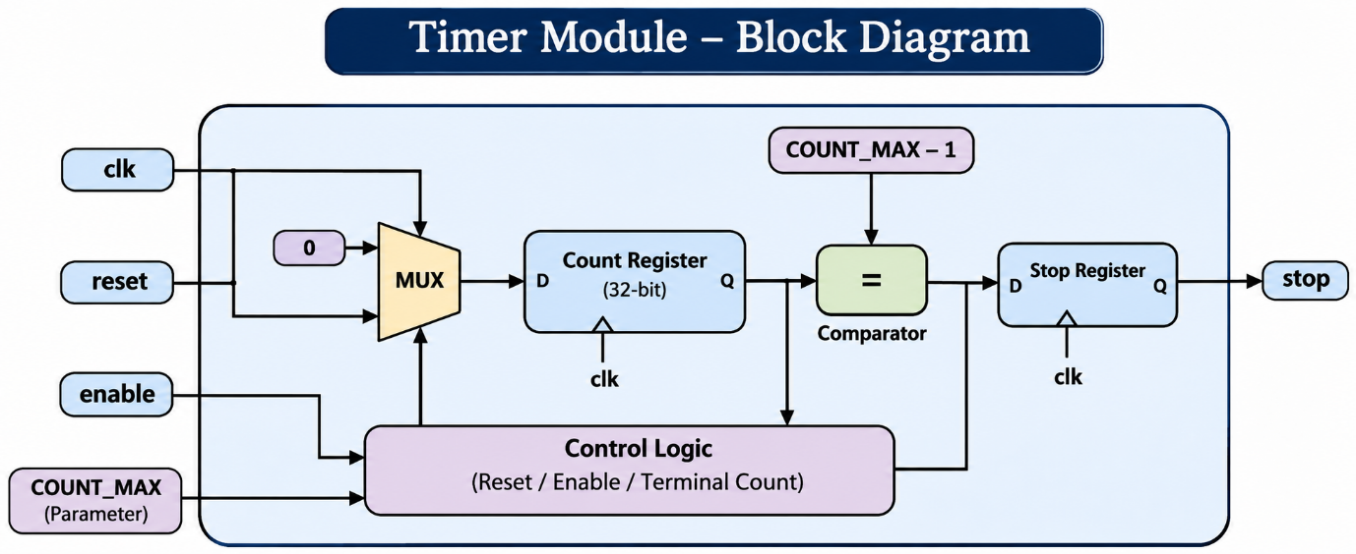

6. Ring Counter
A ring counter is a sequential digital circuit consisting of a shift register in which the output of the last flip-flop is connected to the input of the first flip-flop, forming a closed loop. It circulates a predefined bit pattern with each clock pulse. In a 4-bit ring counter, a single logic '1' circulates through the four flip-flops, producing four distinct states in a repeating sequence. The design is implemented using Verilog HDL in Xilinx Vivado and verified using a testbench and behavioural simulation.
DESIGN:
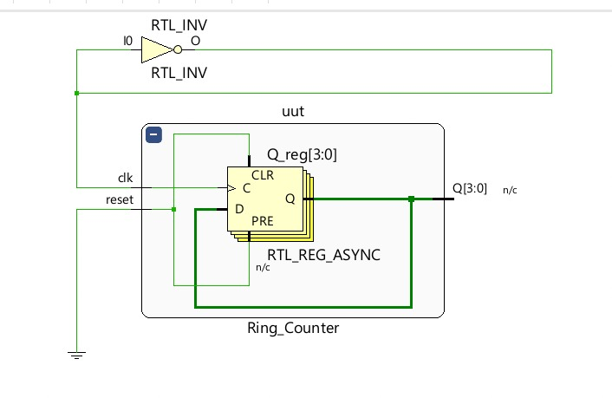

CODE:
`timescale 1ns / 1p
module Ring_Counter (
input clk,
input reset,
output reg [3:0] Q
);
always @(posedge clk or posedge reset) begin
if (reset)
Q <= 4'b0001;
else
Q <= {Q[2:0], Q[3]};
end
endmodule
TESTBENCH:
`timescale 1ns / 1ps
module Ring_Counter_tb;
reg clk, reset;
wire [3:0] Q;
Ring_Counter uut (
.clk(clk),
.reset(reset),
.Q(Q)
);
always #5 clk = ~clk;
initial begin
$monitor("Time=%0t | reset=%b | Q=%b",
$time, reset, Q);
clk = 0;
reset = 1;
#10;
reset = 0;
#50;
$finish;
end
endmodule
WAVEFORM:
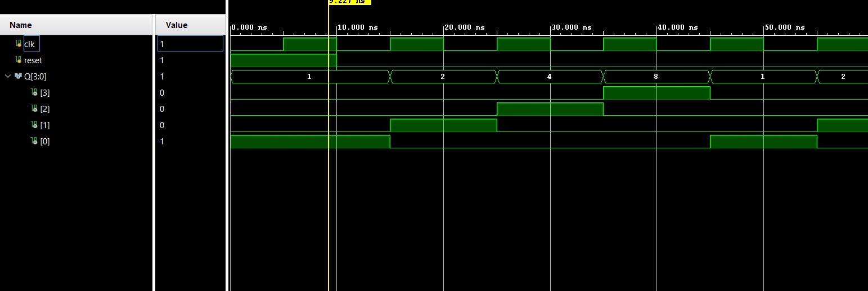
BLOCK DIAGRAM:
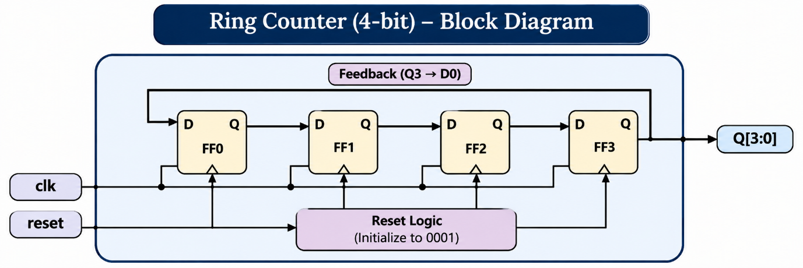

7. Johnson Counter
A Johnson counter is a sequential digital circuit formed by connecting a shift register's complemented output of the last flip-flop to the input of the first flip-flop. On every active clock edge, the data shifts between the flip-flops, generating a sequence of unique states. A 4-bit Johnson counter produces up to eight distinct states before repeating. The design is implemented using Verilog HDL in Xilinx Vivado and verified using a testbench and behavioural simulation.
DESIGN:
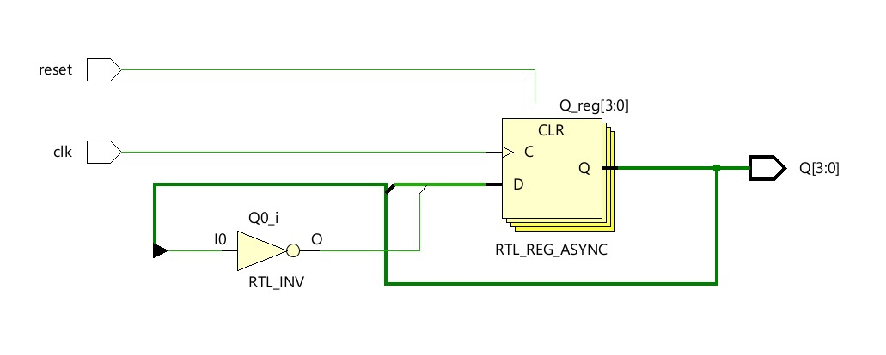
CODE:
`timescale 1ns / 1p
module jhonson (
input clk,
input reset,
output reg [3:0] Q
);
always @(posedge clk or posedge reset) begin
if (reset)
Q <= 4'b0000;
else
Q <= {Q[2:0], ~Q[3]};
end
endmodule

TESTBENCH:
`timescale 1ns / 1p
module jhonson_tb;
reg clk, reset;
wire [3:0] Q;
jhonson uut (
.clk(clk),
.reset(reset),
.Q(Q)
);
always #5 clk = ~clk
initial begin
$monitor("Time=%0t | reset=%b | Q=%b",
$time, reset, Q);
clk = 0;
reset = 1;
#10;
reset = 0;
#80;
$finish;
end
endmodule

WAVEFORM:
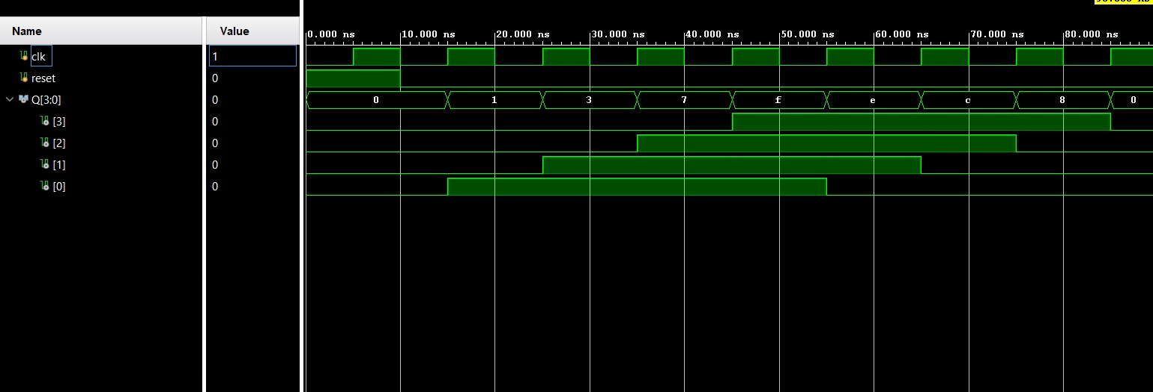
BLOCK DIAGRAM:
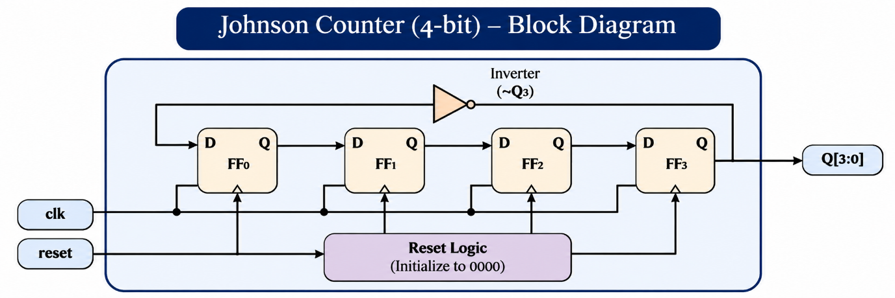

8. Synchronous and Asynchronous Counters
Synchronous:
A synchronous counter is a sequential digital circuit in which all flip-flops receive the same clock signal and change their states simultaneously at the active clock edge. A 4-bit synchronous up-counter increments its binary count by one on each rising edge of the clock. It counts from 0000 to 1111 and then returns to 0000. The design is implemented using Verilog HDL in Xilinx Vivado and verified using a testbench and behavioural simulation.

DESIGN:
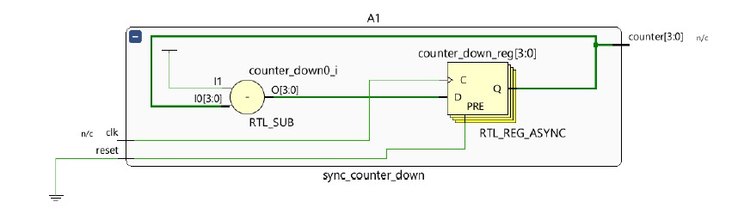
CODE:
`timescale 1ns / 1ps
module synchronous(
input clk,
input reset,
output reg [3:0] Q
);
always @(posedge clk or posedge reset) begin
if (reset)
Q <= 4'b0000;
else
Q <= Q + 1'b1;
end
endmodule
TESTBENCH:
`timescale 1ns / 1ps
module synchronous_tb;
reg clk, reset;
wire [3:0] Q;
synchronous uut (
.clk(clk),
.reset(reset),
.Q(Q)
);
always #5 clk = ~clk;
initial begin
$monitor("Time=%0t | reset=%b | Q=%b",
$time, reset, Q);
clk = 0;
reset = 1;
#10;
reset = 0;
#160;
$finish;
end
endmodule
WAVEFORM:
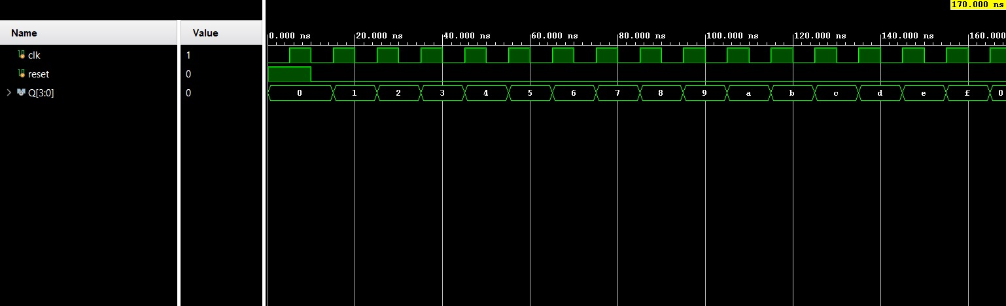
BLOCK DIAGRAM:
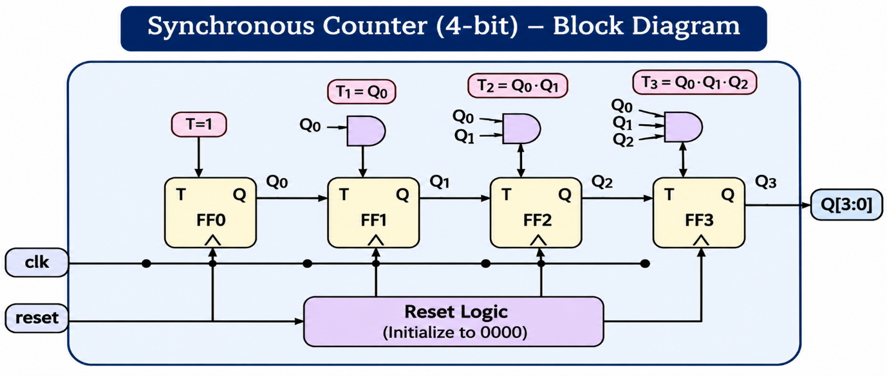
AYSYNCHRONOUS:
An asynchronous counter is a sequential digital circuit in which the external clock is connected to the first flip-flop, while the outputs of preceding flip-flops provide the clock signals for subsequent stages. A 4-bit asynchronous up-counter counts from 0000 to 1111 and then repeats the sequence. Since the flip-flops do not receive the same clock directly, the changes propagate through the stages, producing a ripple effect. The design is implemented using Verilog HDL in Xilinx Vivado and verified through a testbench and behavioural simulation.
DESIGN:
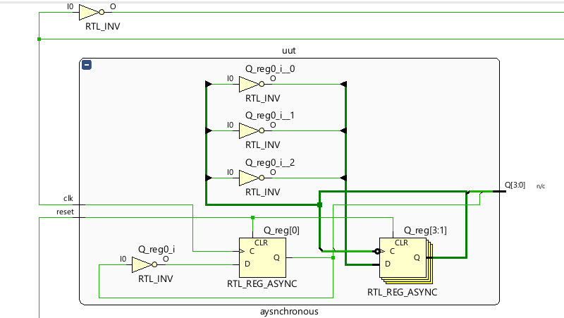
CODE:
`timescale 1ns / 1ps
module aysnchronous(
input clk,
input reset,
output reg [3:0] Q
)
always @(posedge clk or posedge reset) begin
if (reset)
Q[0] <= 1'b0;
else
Q[0] <= ~Q[0];
end
always @(negedge Q[0] or posedge reset) begin
if (reset)
Q[1] <= 1'b0;
else
Q[1] <= ~Q[1];
en
always @(negedge Q[1] or posedge reset) begin
if (reset)
Q[2] <= 1'b0;
else
Q[2] <= ~Q[2];
en
always @(negedge Q[2] or posedge reset) begin
if (reset)
Q[3] <= 1'b0;
else
Q[3] <= ~Q[3];
end
endmodule
TESTBENCH:
`timescale 1ns / 1p
module aysnchronous_tb
reg clk, reset;
wire [3:0] Q
aysnchronous uut (
.clk(clk),
.reset(reset),
.Q(Q)
);

always #5 clk = ~clk
initial begin
$monitor("Time=%0t | reset=%b | Q=%b",
$time, reset, Q)
clk = 0;
reset = 1;
#10;
reset = 0;
#320;
$finish;
end
endmodule
WAVEFORM:
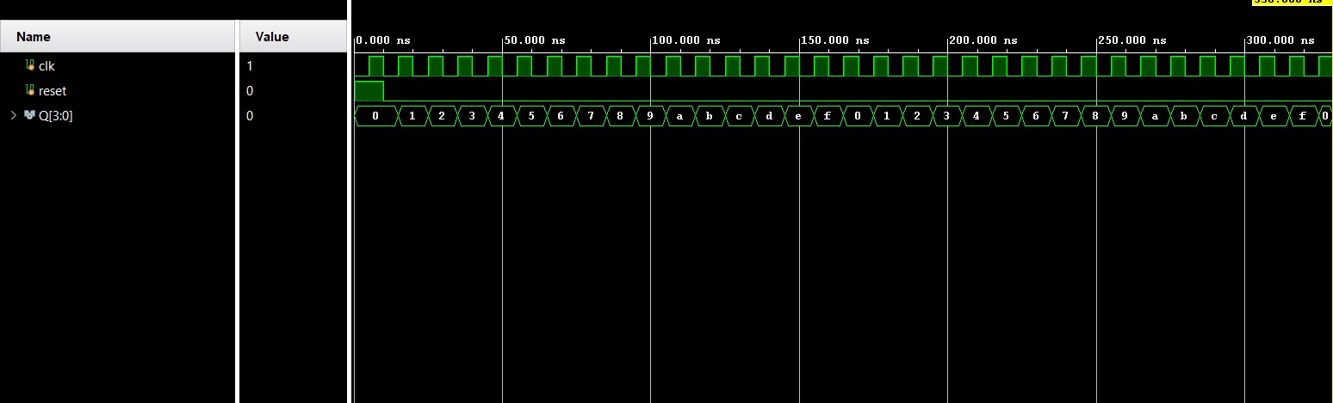
BLOCK DIAGRAM:
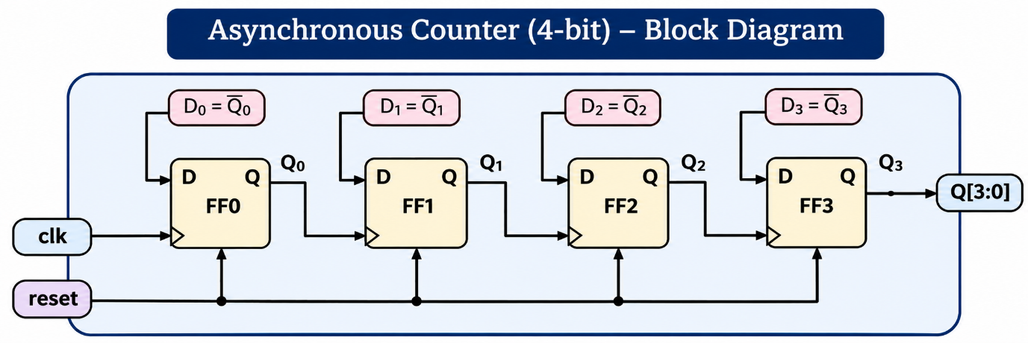

9. Shift Register
A shift register is a sequential digital circuit consisting of a group of flip-flops connected in series, used to store and transfer binary data. With each active clock edge, the data shifts from one flip-flop to the next. Depending on its configuration, a shift register can perform serial-in serial-out (SISO), serial-in parallel-out (SIPO), parallel-in serial-out (PISO), and parallel-in parallel-out (PIPO) operations. The design is implemented using Verilog HDL in Xilinx Vivado and verified using a testbench and behavioural simulation.
DESIGN:
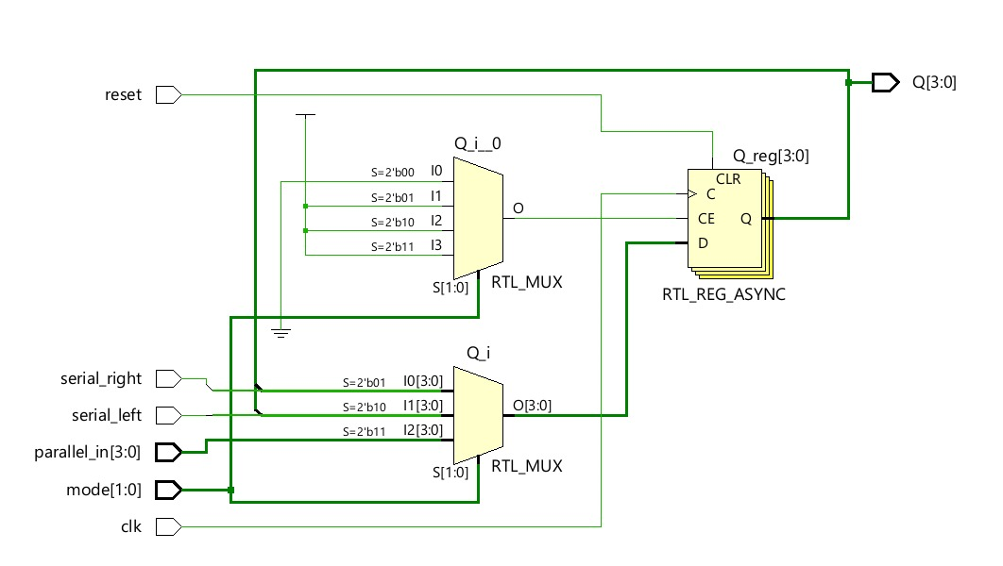
CODE:
`timescale 1ns / 1p
module universal(
input clk,
input reset,
input [1:0] mode,
input [3:0] parallel_in,
input serial_left,
input serial_right,
output reg [3:0] Q
);

always @(posedge clk or posedge reset) begin
if (reset)
Q <= 4'b0000;
else begin
case (mode)
2'b00: Q <= Q;
2'b01: Q <= {serial_right, Q[3:1]};
2'b10: Q <= {Q[2:0], serial_left};
2'b11: Q <= parallel_in;
endcase
end
end
endmodule
TESTBENCH:
`timescale 1ns / 1ps
module universal_tb
reg clk, reset;
reg [1:0] mode;
reg [3:0] parallel_in;
reg serial_left, serial_right;
wire [3:0] Q
universal uut (
.clk(clk),
.reset(reset),
.mode(mode),
.parallel_in(parallel_in),
.serial_left(serial_left),
.serial_right(serial_right),
.Q(Q)
);

always #5 clk = ~clk;

initial begin
$monitor("Time=%0t | reset=%b | mode=%b | parallel_in=%b | Q=%b",
$time, reset, mode, parallel_in, Q)
clk = 0;
reset = 1;
mode = 2'b00;
parallel_in = 4'b0000;
serial_left = 0;
serial_right = 0;
#10 reset = 0;
mode = 2'b11;
parallel_in = 4'b1011;
#10;
mode = 2'b00;
#10;
mode = 2'b01;
serial_right = 1;
#10;
mode = 2'b10;
serial_left = 0;
#10;
mode = 2'b11;
parallel_in = 4'b1100;
#10
$finish;
end
endmodule
WAVEFORM:
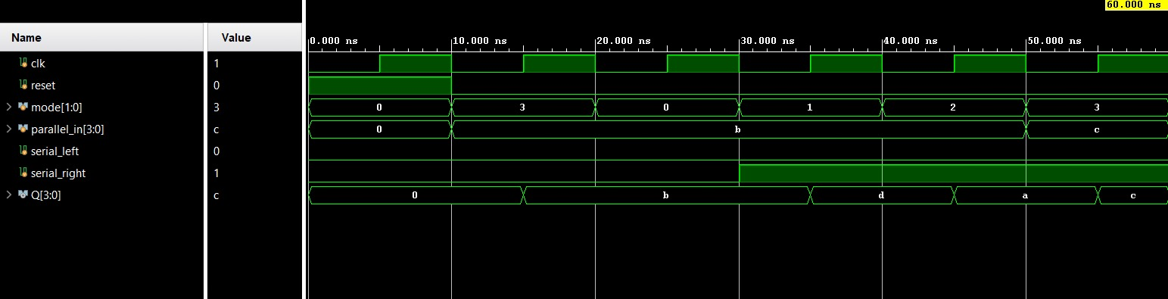
BLOCK DIAGRAM:
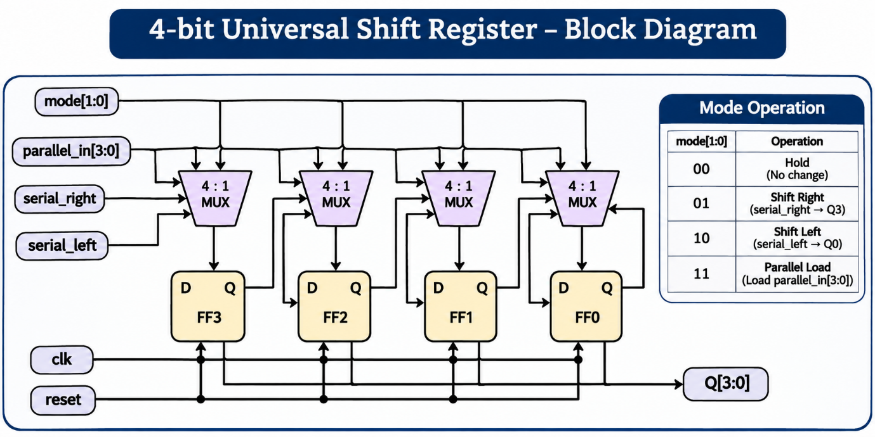

10. Divide-by-N Counter
A Divide-by-N counter is a sequential digital circuit that divides the input clock frequency by a specified integer value, N. It counts incoming clock pulses and resets or changes its output state when the predefined count is reached. This produces an output signal with a frequency related to the input clock frequency by the division factor. Divide-by-N counters are commonly used in frequency division, clock generation, and digital timing applications. The design is implemented using Verilog HDL in Xilinx Vivado and verified using a testbench and behavioural simulation.

DESIGN:
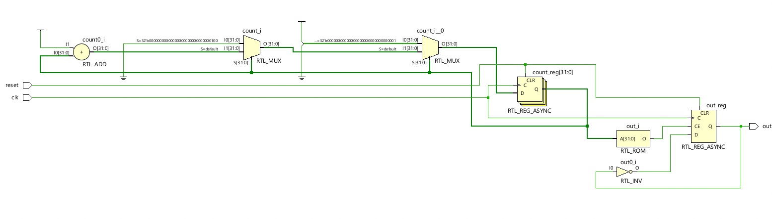
CODE:
`timescale 1ns / 1p
module divide #(
parameter N = 5
)(
input clk,
input reset,
output reg out
);
reg [31:0] count;
always @(posedge clk or posedge reset) begin
if (reset) begin
count <= 0;
out <= 0;
end
else begin
if (count == (N/2 - 1)) begin
count <= count + 1'b1;
out <= ~out;
end
else if (count == (N - 1)) begin
count <= 0;
end
else begin
count <= count + 1'b1;
end
end
end
endmodule
TESTBENCH:
`timescale 1ns / 1ps
module divide_tb
reg clk, reset;
wire out;
divide #(.N(5)) uut (
.clk(clk),
.reset(reset),
.out(out)
);
always #5 clk = ~clk;
initial begin
$monitor("Time=%0t | reset=%b | count=%d | out=%b",
$time, reset, uut.count, out)
clk = 0;
reset = 1;
#10;
reset = 0;
#150;
$finish;
end
endmodule

WAVEFORM:
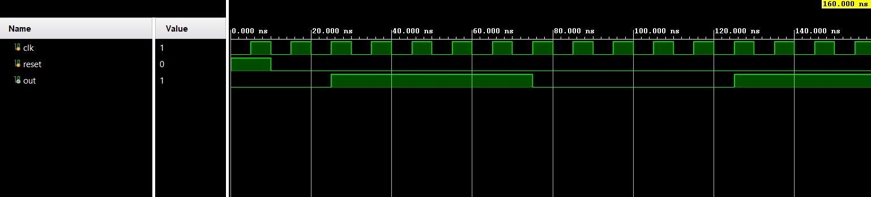
BLOCK DIAGRAM:
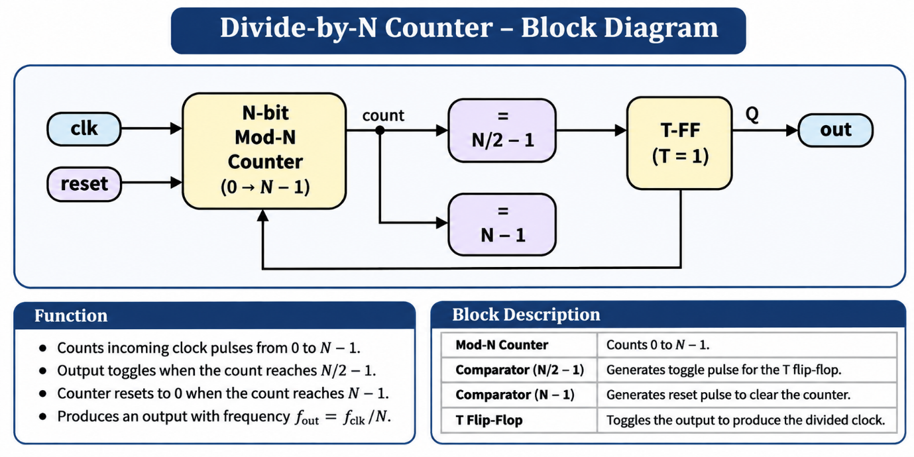

11. Mealy and Moore FSMs
Mealy
A Mealy finite state machine is a sequential digital circuit in which the output depends on both the present state and the current input. The output can change immediately when the input changes, without waiting for the next clock edge, depending on the combinational output logic. In this experiment, a Mealy FSM is designed to detect the input sequence 101. The circuit is implemented using Verilog HDL in Xilinx Vivado and verified using a testbench and behavioural simulation.

DESIGN:
Mealy (1011)
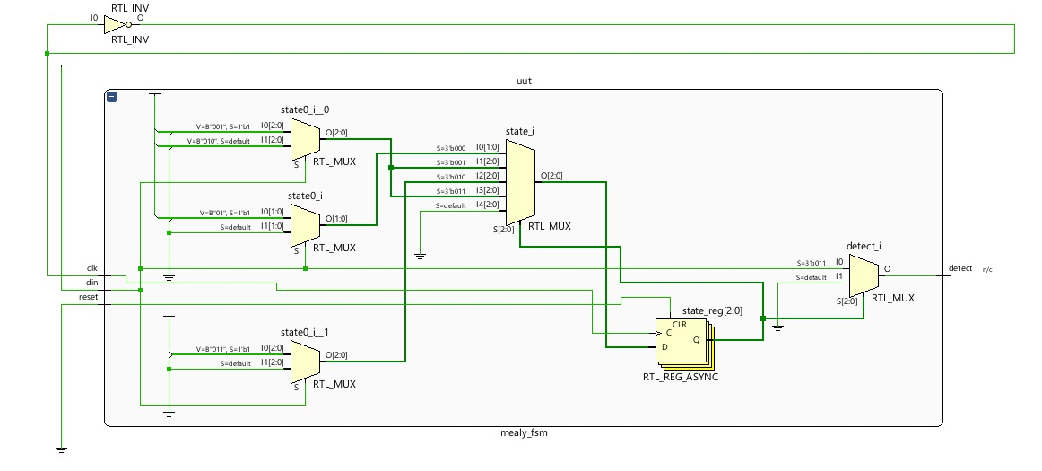
CODE:
`timescale 1ns / 1ps
module mealy_fsm(
input clk,
input reset,
input din,
output reg detect
);
reg [2:0] state
parameter S0 = 3'b000,
S1 = 3'b001,
S2 = 3'b010,
S3 = 3'b011;
always @(posedge clk or posedge reset) begin
if (reset)
state <= S0;
else begin
case (state)
S0: state <= din ? S1 : S0;
S1: state <= din ? S1 : S2;
S2: state <= din ? S3 : S0;
S3: state <= din ? S1 : S2;
default: state <= S0;
endcase
end
en
always @(*) begin
case (state)
S3: detect = din;
default: detect = 1'b0;
endcase
end
endmodule
TESTBENCH:
`timescale 1ns / 1p
module mealy_fsm_tb;
reg clk, reset, din;
wire detect;
mealy_fsm uut (.clk(clk), .reset(reset), .din(din), .detect(detect));
always #5 clk = ~clk;
initial begin
clk = 0;
reset = 1;
din = 0;
#10 reset = 0;
din = 1; #10;
din = 0; #10;
din = 1; #10;
din = 1; #10;

#10 $finish;
end
endmodule

WAVEFORM:
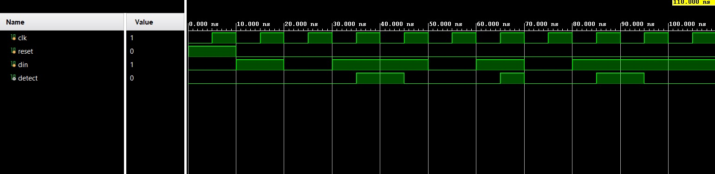
BLOCK DIAGRAM:
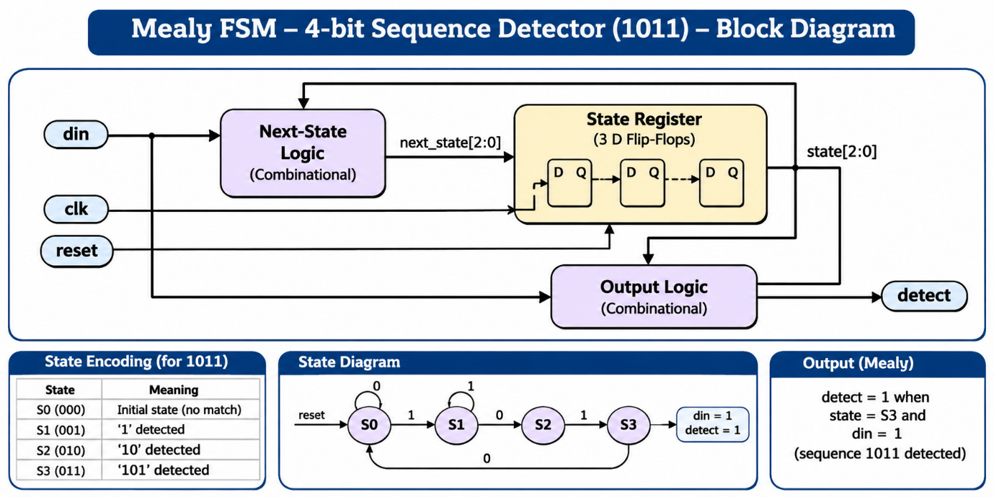

MOORE (1101)
A Moore finite state machine (FSM) is a sequential digital circuit in which the output depends only on the present state. The output changes when the machine transitions from one state to another at a clock edge. In this experiment, a Moore FSM is designed to detect the 4-bit input sequence 1101. The FSM consists of states representing the matched portions of the input sequence and generates a HIGH output when the complete sequence is detected. The design is implemented using Verilog HDL in Xilinx Vivado and verified through a testbench and behavioural simulation.
DESIGN:
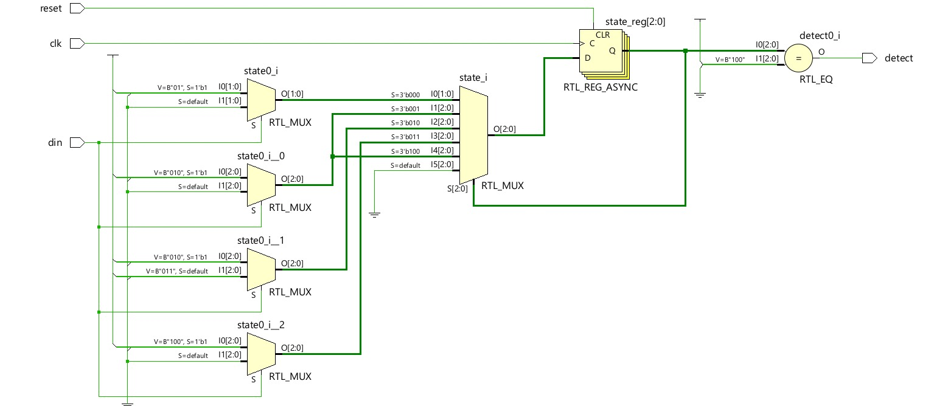
CODE:
`timescale 1ns / 1ps
module MOORE(
input clk,
input reset,
input din,
output reg detect
);
reg [2:0] state;
parameter S0 = 3'b000,
S1 = 3'b001,
S2 = 3'b010,
S3 = 3'b011,
S4 = 3'b100;
always @(posedge clk or posedge reset) begin
if (reset)
state <= S0;
else begin
case (state)
S0: state <= din ? S1 : S0;
S1: state <= din ? S2 : S0;
S2: state <= din ? S2 : S3;
S3: state <= din ? S4 : S0;
S4: state <= din ? S2 : S0;
default: state <= S0;
endcase
end
end
always @(*) begin
detect = (state == S4);
end
endmodule
TESTBENCH:
`timescale 1ns / 1ps
module MOORE_tb;
reg clk, reset, din;
wire detect;
MOORE uut (
.clk(clk),
.reset(reset),
.din(din),
.detect(detect)
)
always #5 clk = ~clk;
initial begin
clk = 0;
reset = 1;
din = 0;
#10 reset = 0;
// Detect sequence 1101
din = 1; #10;
din = 1; #10;
din = 0; #10;
din = 1; #10;
#10 $finish;
end
endmodule

WAVEFORM:
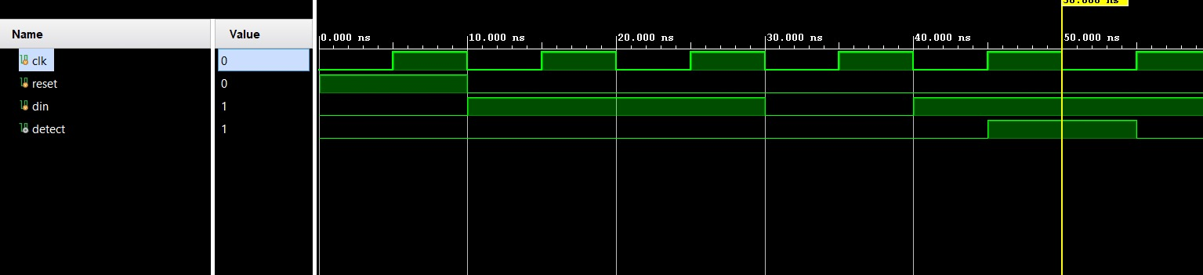

BLOCK DIAGRAM:
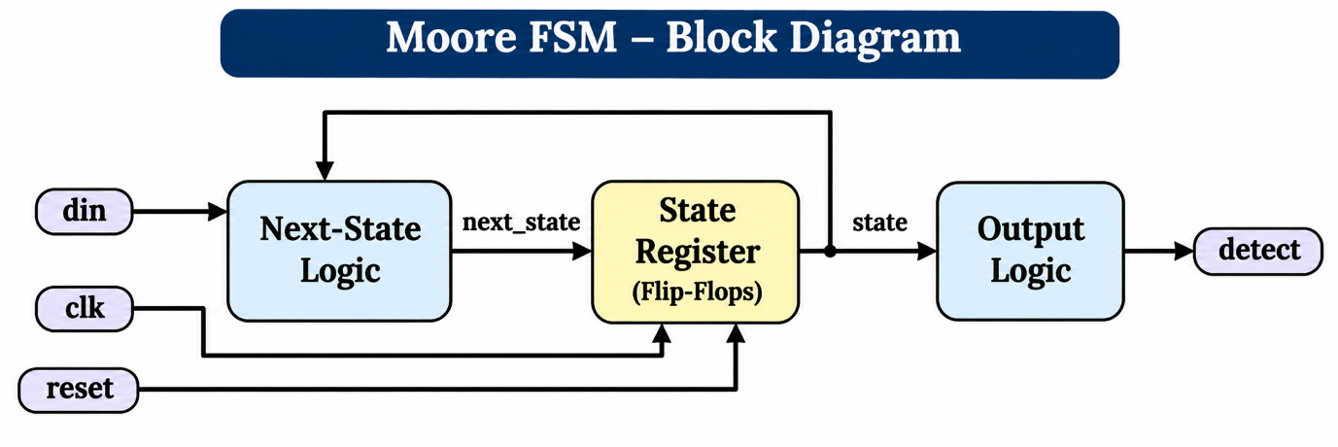

12. Random Sequence Generator
A Random Sequence Generator is a digital circuit that produces a sequence of pseudo-random binary numbers using a Linear Feedback Shift Register (LFSR). It consists of flip-flops connected in a shift-register configuration, with XOR logic providing feedback to generate the next state. In this experiment, a 4-bit LFSR is designed to generate a sequence of binary values, changing on every rising edge of the clock. A reset signal initializes the register to a non-zero starting value. The design is implemented using Verilog HDL in Xilinx Vivado and verified using a testbench and behavioural simulation.
DESIGN:
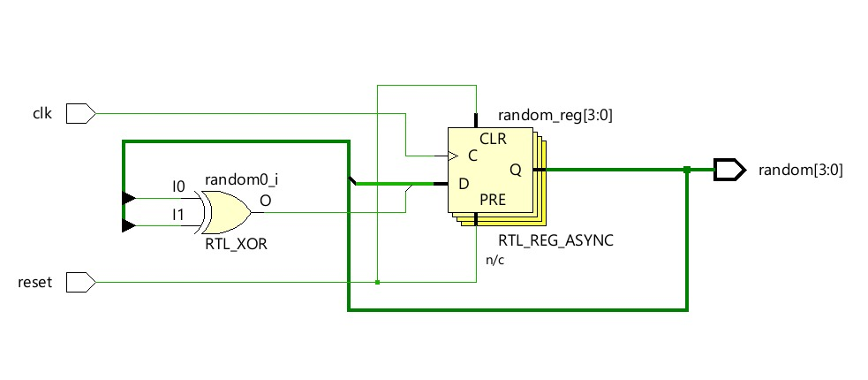

CODE:
module random_seq(
input clk,
input reset,
output reg [3:0] random
);
always @(posedge clk or posedge reset) begin
if (reset)
random <= 4'b0001;
else
random <= {random[2:0], random[3] ^ random[2]};
end
endmodule

TESTBENCH:
module random_seq_generator_tb;
reg clk, reset;
wire [3:0] random;
random_seq uut (
.clk(clk),
.reset(reset),
.random(random)
);
always #5 clk = ~clk;
initial begin
$monitor("Time=%0t | reset=%b | random=%b",
$time, reset, random);
clk = 0;
reset = 1;
#10 reset = 0;
#160 $finish;
end
endmodule

WAVEFORM:
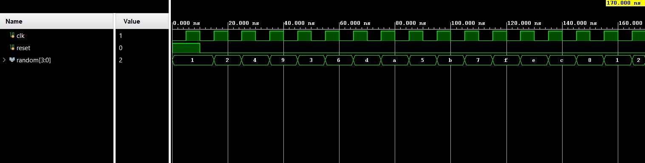

BLOCK DIAGRAM:
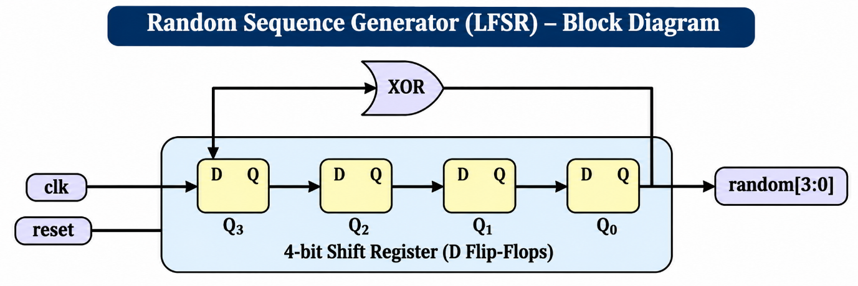

ACKNOWLEDGEMENT
I would like to express my sincere gratitude to Prof. Ajaykumar Devarapalli for his valuable guidance and support throughout the completion of this Alternative Assessment Tool (AAT) report for the course Advanced Digital and Logic Design (ADLD).
I am also thankful to the Department of Electronics and Communication Engineering, BMS College of Engineering, for providing me with the opportunity and academic environment to carry out this work on the design and verification of combinational and sequential digital modules using Verilog HDL.
Finally, I would like to thank everyone who contributed directly or indirectly to the successful completion of this report.

Vismitha JS
USN: 1BF24EC189

